Photoshop Assignment

**Theory Assignments**

Assignment 1: Introduction to Adobe Photoshop

● Tasks:

1. Describe the Photoshop workspace layout and its components (toolbar, panels,

menus).

2. Explain the purpose of differentfile formats (JPEG, PNG, PSD, TIFF) and their use

cases.

3. Discuss the difference between raster and vector images.

ANSWER:-

1. Photoshop Workspace Layout and Its Components

The Photoshop workspace is designed to give users access to all the tools and panels they need for editing images. Its main components include:

=Toolbar

Located usually on the left side.

Contains tools for selection, painting, retouching, cropping, text, and more.

Common tools: Move Tool, Marquee Tool, Brush Tool, Eraser Tool, Lasso Tool, etc.

Some tools have a small triangle at the bottom right corner, indicating more tool options nested within.

= Panels

Usually on the right side of the screen.

Examples include:

Layers Panel: Essential for managing layers.

Properties Panel: Shows context-sensitive settings for layers and tools.

Color, Swatches, History, Adjustments, etc.

Panels can be docked, grouped, or undocked based on user preference.

= Menus

Located at the top of the screen.

Includes:

File (open, save, export),

Edit (undo, transform),

Image (adjustments, mode),

Layer, Select, Filter, View, Window, and Help.

The Window menu allows you to show/hide various panels.

= Options Bar

Appears below the menus when a tool is selected.

Displays custom settings for the active tool.

=Canvas/Document Window

The central area where the actual image being edited is displayed.

2. File Formats in Photoshop:

Purpose and Use Cases

= JPEG (.jpg/.jpeg)

Compressed raster format with lossy compression.

Small file size, good for web and social media.

Best for: Photographs and images where quality loss is acceptable.

Not suitable for: Editing later (no layers), or images needing transparency.

= PNG (.png)

Lossless raster format, supports transparency (alpha channel).

Larger file size than JPEG, but better for images with sharp edges, like icons, logos.

Best for: Web graphics, UI elements, images needing transparency.

Not ideal for: Photos or print work due to larger size.

= PSD (.psd)

Photoshop's native file format.

Supports layers, effects, masks, text, and adjustments.

Best for: Editable Photoshop projects and working files.

Not suitable for: Web or external sharing (too large, not universally supported).

= TIFF (.tif/.tiff)

High-quality raster format, supports layers and lossless compression.

Preferred in printing and publishing.

Best for: Print projects, archiving high-quality images.

Not ideal for: Web use (large file sizes).

3. Raster vs. Vector Images

Feature Raster Images Vector Images

Made of Pixels (tiny squares of color) Paths defined by mathematical equations

Scalability Loss of quality when enlarged Infinitely scalable without loss

Best for Photos, digital paintings, textures Logos, icons, illustrations, typography

File Types JPEG, PNG, PSD, TIFF AI (Adobe Illustrator), SVG, EPS

Editing Pixel-by-pixel in Photoshop Shape/path-based in Illustrator

Raster: Great for detailed imagery but limited in scalability.

Vector: Ideal for clean, crisp graphics that may need to be resized often.

**Assignment 2: Layers and Masking**

**● Objective: Learn the importance oflayers and how to use masks.**

**● Tasks:**

**1. Explain what layers are in Photoshop and how they affectthe editing process.**

**2. Describe the concept oflayer masks and their benefits.**

**3. Write aboutthe difference between adjustment layers and regular layers.**

**4. How to Deal with an Index Layer?**

ANSWER:-

1. What Are Layers in Photoshop and How Do They Affect the Editing Process?

Layers in Photoshop are like sheets of transparent paper stacked on top of each other. Each layer can hold different elements—such as images, text, brush strokes, shapes, or effects—without affecting the other layers. This allows for non-destructive editing.

How They Affect Editing:

Flexibility: You can work on individual parts of a project without altering the rest.

Organization: Keeps complex projects structured.

Efficiency: Easy to adjust or remove specific changes.

Blending Options: Layers can be blended using different modes (e.g., Multiply, Screen).

Reversibility: You can turn layers on/off or adjust opacity without losing data.

2. What Are Layer Masks and Their Benefits?

A layer mask is a powerful tool that allows you to hide or reveal parts of a layer without permanently deleting any content. Masks work in grayscale:

White = visible

Black = hidden

Gray = partially visible (transparency)

Benefits of Layer Masks:

Non-destructive editing: You can modify or reverse masking at any time.

Smooth transitions: Create soft edges and blends between elements.

Precision: Allows localized adjustments on parts of a layer.

Control: You can use gradients, brushes, and selections to define what’s visible.

3. Adjustment Layers vs. Regular Layers

Feature Adjustment Layers Regular Layers

Purpose Apply effects like brightness, contrast, hue/saturation Hold content like images, text, or paint

Editable? Yes, fully editable and reversible Content needs manual changes or redoing

Affect Other Layers? Can affect all layers beneath them Only represent their own contents

Non-destructive? Yes Not inherently—depends on how they’re used

Examples of Adjustment Layers:

Brightness/Contrast

Curves

Hue/Saturation

Levels

Black & White

4. How to Deal with an Index Layer

An Index layer means the image is in Indexed Color Mode, which limits it to a fixed palette (like 256 colors). You cannot directly edit layers (e.g., apply filters or use masks) in this mode.

How to Fix It:

Go to Image > Mode > RGB Color

This will convert the image to RGB mode, allowing full editing capabilities.

After that, the Index layer becomes a normal layer, and you can unlock/edit it freely.

**Assignment 3: Color Theory and Image Adjustments**

**● Objective: Understand color theory and image adjustments.**

**● Tasks:**

**1. Discuss the color wheel and the significance of primary, secondary, and tertiary**

**colors.**

**2. Explain differentimage adjustmenttools (Brightness/Contrast, Levels, Curves).**

**3. Define the terms "Hue," "Saturation," and "Lightness" in the context ofimage**

**editing.**

ANSWER:-

1. The Color Wheel and the Significance of Primary, Secondary, and Tertiary Colors

The color wheel is a visual representation of colors arranged according to their chromatic relationship. It helps artists and designers understand how colors interact, allowing them to create balanced and harmonious designs.

Primary Colors:

Red, Blue, Yellow

Cannot be made by mixing other colors.

All other colors are derived from these.

Secondary Colors:

Orange, Green, Purple

Made by mixing two primary colors:

Red + Yellow = Orange

Blue + Yellow = Green

Red + Blue = Purple

Tertiary Colors:

Made by mixing a primary and a secondary color.

Examples: Red-Orange, Blue-Green, Yellow-Green, etc.

Significance in Design and Editing:

Helps in choosing complementary colors for contrast.

Guides analogous color schemes for harmony.

Used for mood creation (e.g., warm vs cool tones).

2. Image Adjustment Tools: Brightness/Contrast, Levels, and Curves

These tools are used to improve exposure, contrast, and tonal balance in images.

Brightness/Contrast:

Brightness: Lightens or darkens the entire image uniformly.

Contrast: Increases or decreases the difference between the lightest and darkest areas.

Use when you want quick, general fixes.

Levels:

Adjusts shadows, midtones, and highlights using a histogram.

You can drag sliders to set the black point, white point, and midtone gamma.

Use for correcting exposure and enhancing tonal range.

Curves:

A more advanced tool than Levels.

Provides a graph (tone curve) to adjust brightness and contrast across specific tonal areas.

You can add multiple anchor points for precise control.

Use for fine-tuning lighting, contrast, or creating stylized color grading.

3. Definitions: Hue, Saturation, and Lightness

These three terms are fundamental to understanding and controlling color in digital image editing:

Hue:

Refers to the color family (e.g., red, blue, green).

It’s what we typically think of as “color.”

Adjusting hue shifts the overall color tone of an image.

Saturation:

Refers to the intensity or purity of a color.

High saturation = vivid, bold colors.

Low saturation = muted or grayscale appearance.

Useful for creating dramatic effects or a more subdued look.

Lightness (or Luminance/Brightness):

Refers to how light or dark a color is.

0% = black, 100% = white.

Changing lightness affects the visibility and mood of the image.

**Assignment 4: Text and Typography in Photoshop**

**● Objective: Explore text and typography tools in Photoshop.**

**● Tasks:**

**1. Discuss the importance oftypography in design and how itimpacts visual**

**communication.**

**2. Explain the various texttools available in Photoshop and their functionalities.**

**3. Describe how to apply effects and styles to text layers.**

ANSWER:-

Objective:

Explore text and typography tools in Photoshop to understand how they enhance visual communication and design quality.

= 1. Importance of Typography in Design

Typography plays a critical role in how a message is perceived. Here's why it's important:

= Visual Communication

Typography conveys tone, emotion, and meaning even before a word is read.

Example: A bold, uppercase font communicates strength, while a script font might feel elegant or personal.

= Hierarchy and Readability

It helps guide the viewer’s eye through a design.

Different font sizes, weights, and styles can emphasize important elements like titles or calls to action.

= Brand Identity

Fonts contribute to a brand’s personality and consistency.

Example: Tech brands may use clean, sans-serif fonts; fashion brands might use stylish serifs.

= User Engagement

Well-designed typography increases readability, keeping users engaged longer.

=2. Text Tools in Photoshop and Their Functionalities

Photoshop provides powerful tools for working with text. Here’s a quick overview:

= Horizontal Type Tool (T)

Primary text tool.

Creates left-to-right horizontal text layers.

Supports live editing: you can change font, size, spacing, etc.

= Vertical Type Tool

Creates text that flows top-to-bottom vertically.

= Horizontal and Vertical Type Mask Tools

Create text-shaped selections instead of editable text layers.

Often used to clip images inside text or make text cutouts.

🔠 Text Formatting Options (Top Options Bar & Character Panel)

Change font family, size, leading (line spacing), tracking (letter spacing), etc.

Apply bold, italic, underline, and text alignment (left, center, right).

Choose between point text (click to add a line of text) or paragraph text (drag to create a text box).

=3. Applying Effects and Styles to Text Layers

Photoshop allows for a variety of effects to enhance text visually:

=Layer Styles (Right-click > Blending Options or fx button)

You can apply:

Drop Shadow – adds depth behind text.

Stroke – outlines the text with color or gradient.

Outer Glow/Inner Glow – gives a glowing effect around or inside the text.

Bevel & Emboss – gives a 3D look to the text.

Gradient Overlay / Color Overlay / Pattern Overlay – fills text with colors, gradients, or textures.

= Smart Objects & Filters

Convert text to a Smart Object to apply filters (e.g., Blur, Distort) non-destructively.

Great for advanced effects while keeping text editable.

=Warp Text

Accessed from the top options bar when text is selected.

Lets you apply preset warp styles (arc, wave, flag, etc.) for creative distortion.

= Transform Text

Use Ctrl+T / Cmd+T to resize, rotate, skew, or distort the text manually.

Combine this with Free Transform > Warp for custom shapes.

= Summary:

Typography in Photoshop is much more than adding words—it's a design element. With the right tools and styles, you can create text that speaks visually, aligns with your brand, and engages the audience.

**Practical Assignments**

**Practical Assignment 1: Create a Simple Poster ● Objective: Apply basic Photoshop tools to design a poster.**

**POSTER**

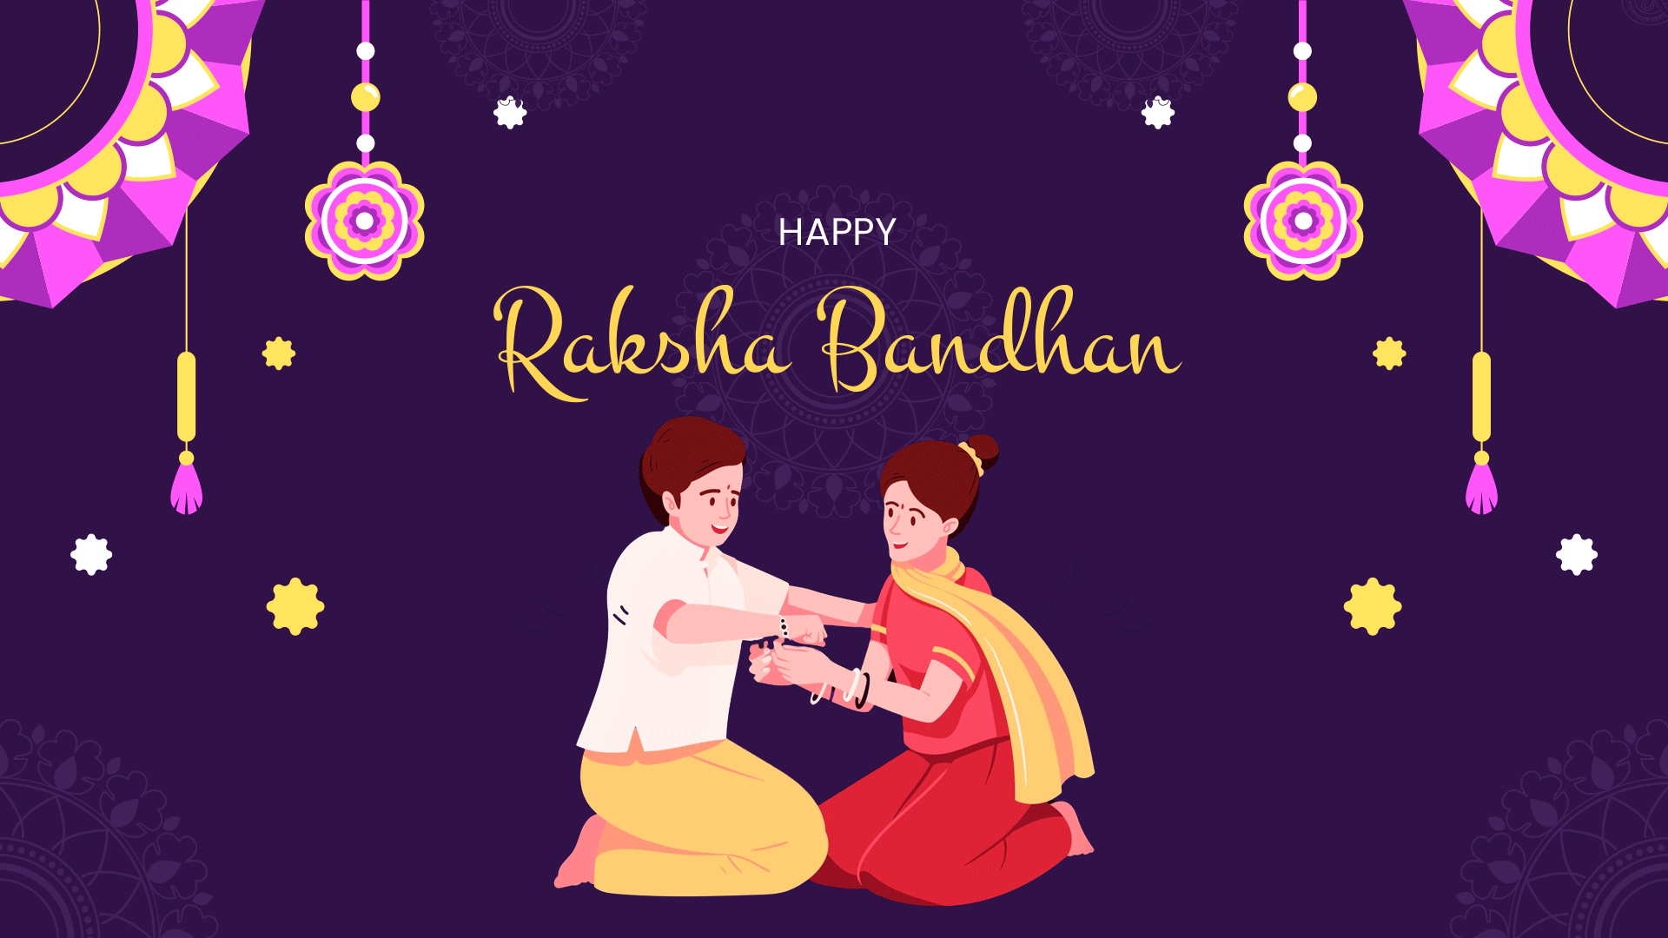

**Photo Manipulation**

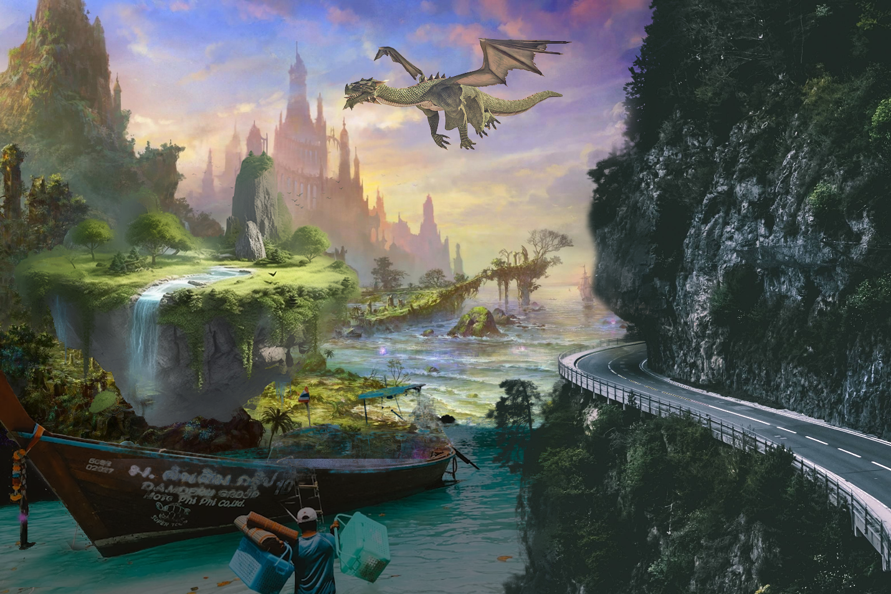

**Text Effects**

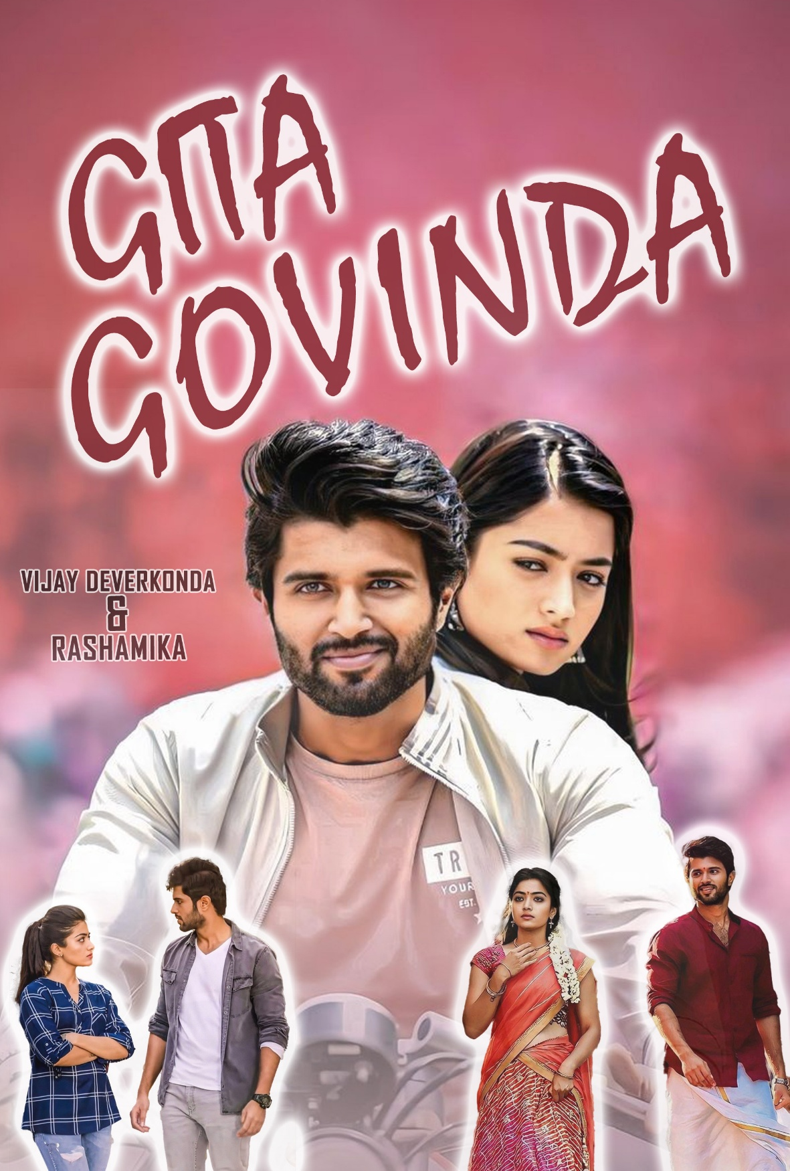

**SIDE EFFECTS**

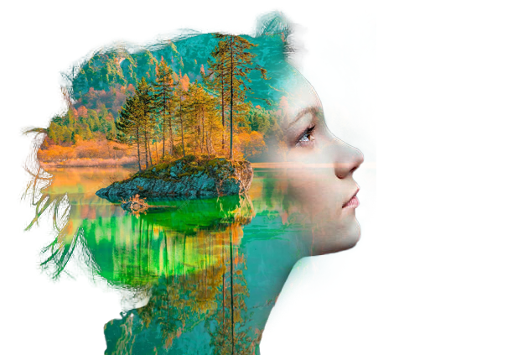

**Creating actions**

